Perrysburg Junior High School
Announcements
February 16, 2024

IMPORTANT DATES

February 19 Presidents Day - No School
February 23 Winter Spirit Assembly
February 27 8th Grade Visit Penta Career Center
March 1 2 Hour Delay - Staff PD Day
March 7 Grandparents Raising Grandchildren Support Group (information below)
March 8 End of Quarter 3
March 19 No School - Election Day
March 25 - 29 No School - Spring Break
April 1 Students Return
April 2 State Test - ELA Day 1
April 4 State Test - ELA Day 2
April 8 No School
April 16 State Test - Math Day 1
April 18 State Test - Math Day 2
April 23 State Test (8th Grade Only) - Science Day 1
April 23 7th Grade Day 1 of YouScience Career Inventory
April 25 State Test (8th Grade Only) - Science Day 2
April 25 7th Grade Day 2 of YouScience Career Inventory
May 3 8th Grade Visit PHS for FroshFest
May 17 Spring Spirit Assembly
May 22 Last Day School for 7th & 8th Students
8th Grade Recognition Ceremony and Dance at PHS, 6pm
May 23 PJHS Meet You in the Middle - 6th Grade Students Visit PJHS

JHPO
Would you make a good Junior High Parent Organization (JHPO) Dance Chair? Or a JHPO Treasurer? Or like to contribute in another way to support the students and staff of PJHS through JHPO? As a two year school we have significant turnover in parent volunteers each year and so we are always welcoming new parents to join us. Our next meeting is Wednesday, 2/21/24, at 6:30pm in the PJHS library. We welcome 6th grade parents whose students will be attending PJHS next year, as well as 7th and 8th grade parents, at next week's meeting and all meetings through the end of the year. We look forward to meeting you!

Food Drive
The district ROX groups are collecting food items for a Spring Dinner Food Drive March 1-19. The Junior High will be collecting cans of corn and cans of yam. Please place any donations in a collection box outside of the main office.

Lost & Found From Buses
Attached are items that have been left on buses. If any of these items belong to you, please pick them up at the Transportation Department, 25715 Ft. Meigs Road. All unclaimed items will be donated. Any questions please call, 419-874-3127 ext. 2702. LostandFound1.jpg LostandFound2.jpg
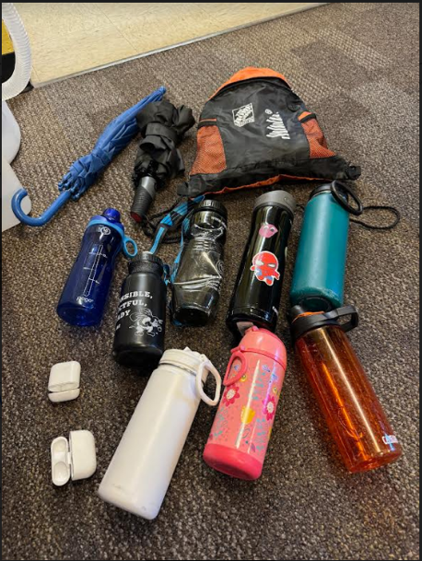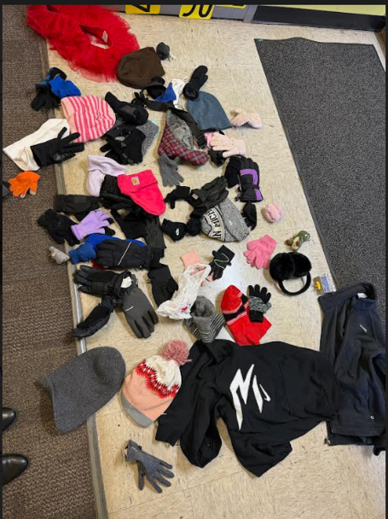

Yearbook:
The DEADLINE to order a yearbook is March 1st for $40. After that, they will be available on a first come first served basis at school when books arrive in May.
https://www.jostens.com/apps/store/productBrowse/1048662/Perrysburg-Junior-High-School/2024-Yearbook/20230805043456087125/CATALOG_SHOP/

Important Information from the Treasurer's Office
Attention parents, as you may be aware, check/banking fraud is on the rise. This is one of the reasons, as a district, we prefer electronic transactions. We are aware that electronic payment methods are not best for all families. If your preference is to write a check/money order, please make them payable to either "Perrysburg Schools" or "Perrysburg Exempted Village Schools." You may utilize the memo line to indicate the specific purpose for the check (e.g. Student name - lunch acct, school fees, athletic fee, etc). We appreciate your assistance in maintaining the integrity of our financial transactions and protecting both our families and the district from potential fraud risks.

Go Jackets!
*********************************************************************

OTHER IMPORTANT INFORMATION:

February Menu:
https://www.myschoolmenus.com/organizations/1561/sites/11134/menus/52720?date=2024-02-01&view=monthly

Early Departures:
Parents will need to come to the office to sign your student out if they are leaving early. To notify us of the appointment, you have 2 options:
- send a note with your student to give to the Student Services Office before school begins in the morning OR
- Use the SafeArrival System in one of these ways (See Directions Below)
An early dismissal pass will be issued which will allow the student to leave class at the designated time. The student will be waiting in the vestibule in the main office for your arrival.
A doctor's note should be obtained for the absence to be considered exempt. A parent/guardian must come in the building to sign the student out. If the student is returning from the appointment, they do not need to be accompanied.

Grandparents Raising Grandchildren:
The Wood County ESC has partnered with Perrysburg Schools to provide the Grandparents Raising Grandchildren Support Group, which meets monthly from 6-7:30pm through the rest of the school year at Frank Elementary. GRG-updated flyer (1).pdf It is designed to have a space for grandparents to receive support and also have a separate supervised space for the grandchildren that they are raising. Dinner will be provided at each meeting.

JHPO
Help JHPO support students, teachers, and staff of PJHS by:
--Liking our Facebook page, @PerrysburgJHPO
-Liking our Instagram page, @JHPOPerrysburg
-Volunteering time or making donations to student fun and staff appreciation events which will be announced on our social media and the in the school emails
-Making a monetary donation to JHPO by check mailed to or dropped at school or through Venmo to @jhpoperrysburg
-Participating in Box Tops for Education for 'Perrysburg Junior High School': https://www.boxtops4education.com/s/get-the-app
-Participating in Kroger Community Rewards for Org. UV412: https://www.kroger.com/i/community/community-rewards
-Participating in Office Depot/Office Max Give Back to Schools Program for ID 70079938: https://www.officedepot.com/cm/school-supplies/give-back
We look forward to a fun year for our school community!

School Fees:
School Fees are due. Please go to https://www.payschoolscentral.com/. to make payment. (Attached is the Parent User Guide to set up your account) PaySchoolCentralParentUserGuide.pdf You can also pay by check payable to “Perrysburg Schools”. Please indicate your student on the memo line.

Student Absence Reporting System:
SafeArrival for all grades, preschool through 12.
With SafeArrival, you are asked to report your child’s absence in advance using any of these three methods:
1. App - Using your mobile device, download and install the SchoolMessenger app from the Apple App Store or the Google Play Store (or from the links at go.schoolmessenger.com).
2. Website - Use the SafeArrival website, go.schoolmessenger.com
3. Call - Call the toll-free number (844) 393-6016
These options are available 24 hours/day, 7 days a week.
Please enter 844-393-6016 into your phone address book as Perrysburg Schools Attendance Line right away, so if you receive a call it will not be seen as a potential spam call.
Please note: Personal Convenience/Pre-Planned Absences are still handled through your school office and cannot be entered by parents/guardians in SafeArrival. Please start by using this form: https://files.neola.com/perrysburg-oh/search/forms/fm5200F1.pdf.

****************************************************************************************************
Safer Ohio School Tip Line - 844-723-3764
This is a free service that accepts calls and texts 24/7 and allows anyone to anonymously share information with school officials and law enforcement about threats to safety.

Crisis Text Line - text “4hope” to 741 741
People of all ages may reach out by text 24/7 to communicate with someone trained to listen and respond in a method that is free, private, secure and confidential. Data usage while texting Crisis Text Line is free and the number will not appear on a phone bill with the mobile service carrier.

